

PROPOSAL DOCUMENT

UH Backups and Replications

© Sautech (Pty) Ltd. http://www.sautech.net

TABLE OF CONTENTS

1. INTRODUCTION 3
2. Replications 3
3. Primary Replication 3
4. Secondary Replication (Exdended DR) 3
5. Backups 4
6. Primary Replication Failover 4
7. DR Replication Failover 4
8. Backup Failover 5
9. Infrastructure diagram 5

INTRODUCTION

The purpose of this document is to explain UH Replications and backups with process and a how to guide to assist to do the backups and monitoring if the backups are running successfully.

MICROSOFT HYPER-V REPLICATIONS
    - UH has two sets of Replications
    - Primary Replications that acts as a failover within the same Datacentre
    - Secondary Replication (DR) that acts as a failover to a 2nd Datacentre

MICROSOFT HYPER-V Primary Replication
  - UH has 2 Server as MTN Gallo Manor (Afrihost), the Primary and Secondary Server
  - On the Primary there is 3 x Virtual Machine (Ambledown VIP, Test Production, Production) that gets replicated to the 2nd Server with incrementals of every 15min with a total of 24 Restore point.



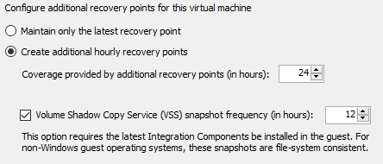

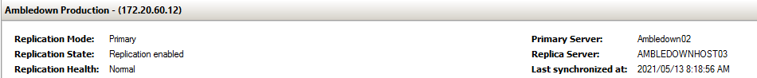

MICROSOFT HYPER-V Secondary Replication (Exdended DR)
  - The 3 x Virtual Machine on the Secondary Server gets replicated (Extended Rep) to a 2nd Datacentre that is at Xneelo Samrand with a 15min incremental and a total of 24 restore point.

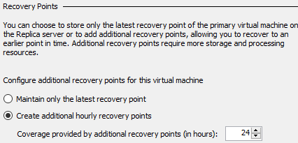

Primary Replication Failover
  - Primary Failover will occur if the following applies
    - Virtual Machine Failure
    - Windows Updates Failure which caused server not to start
    - Application Failure
    - Databases Deleted / Corrupted
    - Primary Server Failure
  - Acting Company Responsible for calling Primary Replication Failover = Sautech

DR Replication Failover
  - DR Failover will occur if the following applies
    - MTN Gallo Manor (Afrihost) is completely down
    - Primary and Secondary Server complete Failure
  - Additional conditions apply for calling DR Replication Failover
    - UH DR policy should be in effect and active
    - DR Failover will occur in a certain period that is stipulated in the DR policy of UH
    - When there is no way of restoring the Primary services within the time frame of the DR policy of UH
  - Acting Company Responsible for calling DR Replication Failover = UH

Backups
  - The 3 x Virtual Machine at the DR Datacentre gets backed up to achieve the following schedules
    - Daily with a total of 30 Restore point
    - Weekly with a total of 52 Restore points
    - Monthly with a total of 12 Restore points

Backup Failover
  - Backup Failover will occur if the following applies
    - All data is missing exceeding the time frame of available Primary and DR Replications
    - Data encryption with all Primary and DR replications infected
    - Acting Company Responsible for calling DR Replication Failover = UH

Infrastructure diagram

